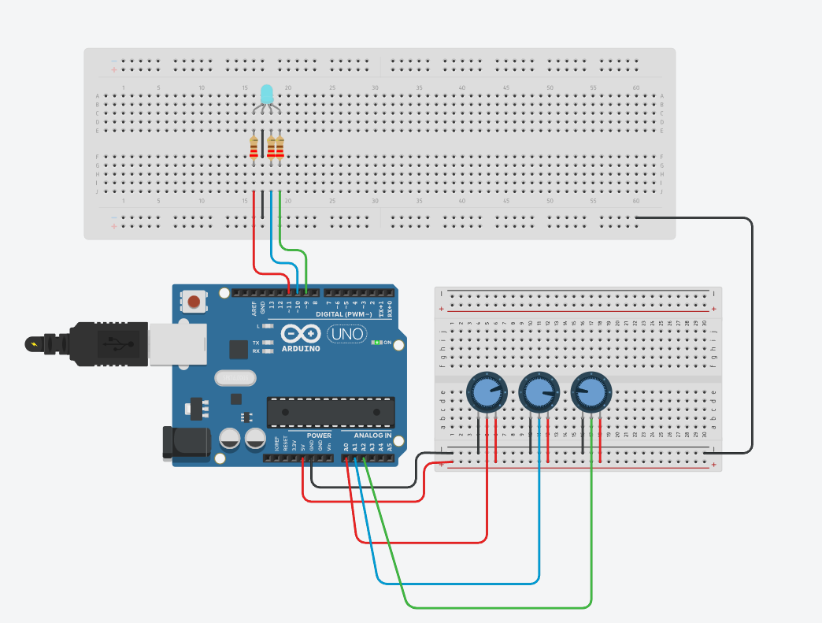

#define RED_PIN 9

#define GREEN_PIN 10

#define BLUE_PIN 11

#define POT_RED A0

#define POT_GREEN A1

#define POT_BLUE A2

void setup() {

Serial.begin(9600);

pinMode(RED_PIN, OUTPUT);

pinMode(GREEN_PIN, OUTPUT);

pinMode(BLUE_PIN, OUTPUT);

}

void loop() {

int redValue = analogRead(POT_RED);

int greenValue = analogRead(POT_GREEN);

int blueValue = analogRead(POT_BLUE);

redValue = map(redValue, 0, 1023, 0, 255);

greenValue = map(greenValue, 0, 1023, 0, 255);

blueValue = map(blueValue, 0, 1023, 0, 255);

analogWrite(RED_PIN, redValue);

analogWrite(GREEN_PIN, greenValue);

analogWrite(BLUE_PIN, blueValue);

delay(100);

}